Document Summarization

George Pashev

<http://gpashev.com>

### **Slide 1: Overview of Computational Linguistics**

****Title****: Introduction to Computational Linguistics

****Content****:

* ****Definition****: Computational Linguistics (CL) is an interdisciplinary field that leverages computer science to process and analyze large volumes of natural language data.
* ****Objective****: The main goal is to enable computers to understand and interpret human (natural) languages to perform various tasks such as translation, sentiment analysis, and text summarization.
* ****Applications****: CL is fundamental in developing applications like voice-activated assistants, automated translation services, and information retrieval systems.
* ****Importance****: In the age of information, CL helps manage and make sense of the vast amounts of text data generated daily, enhancing accessibility and understanding for both businesses and individuals.

### **Slide 2: Introduction to Text Summarization**

****Title****: What is Text Summarization?

****Content****:

* ****Definition****: Text summarization is a process in Computational Linguistics aimed at creating a concise and coherent summary of a longer text document.
* ****Purpose****: It helps in quickly understanding the main points of a document without needing to read the entire text, saving time and effort.
* ****Types****:
  + Extractive Summarization: Involves selecting and compiling parts of the original text to form a summary.
  + Abstractive Summarization: Generates a new, shorter text that conveys the most critical information from the original document, often mimicking human summarization capabilities.

### **Slide 3: Importance of Text Summarization in Big Data and Information Retrieval**

****Title****: Role of Text Summarization in the Era of Big Data

****Content****:

* ****Big Data Challenges****: With the exponential growth of digital information, summarization aids in managing, navigating, and making sense of large datasets.
* ****Information Retrieval Enhancement****: Summarization improves the efficiency of information retrieval systems by providing quick insights into the content, enhancing search engine functionality and user experience.
* ****Decision Making****: In business and research, summarization tools help stakeholders quickly grasp essential insights from reports, reviews, and research, aiding in faster decision-making processes.
* ****Accessibility****: Summarization contributes to accessibility by allowing individuals to consume information more efficiently, especially those with reading difficulties or time constraints.

### **Slide 4: Challenges in Single Document Summarization**

****Title****: Challenges Facing Single Document Summarization

****Content****:

* ****Content Reduction****: Identifying the most critical information while ensuring the summary remains coherent and representative of the original text.
* ****Context Preservation****: Maintaining the original context and meaning without introducing bias or altering the intended message.
* ****Language Nuances****: Dealing with linguistic subtleties, idiomatic expressions, and the diverse structure of languages which can complicate summarization efforts.
* ****Subjectivity****: Balancing the summary's objectivity, especially in documents with ambiguous or subjective content, requires sophisticated understanding and interpretation.

### **Slide 5: Techniques for Single Document Summarization**

****Title****: Techniques in Single Document Summarization

****Content****:

* ****Extractive Summarization****:
  + Definition: Involves selecting significant sentences or fragments directly from the original text to compile a summary.
  + Techniques: Algorithms like TextRank or LexRank analyze the text's structure and word frequencies to identify key sentences.
* ****Abstractive Summarization****:
  + Definition: Generates new phrases and sentences to capture the essence of the original text, often leading to more natural and concise summaries.
  + Approaches: Utilizes advanced machine learning models, such as sequence-to-sequence and transformer models, to understand and reproduce the core meanings in a condensed form.

These slides set the stage for a comprehensive and engaging presentation on text summarization in Computational Linguistics, providing a solid foundation for understanding the challenges and techniques involved in summarizing single documents.

### **Slide 6: Key Algorithms and Their Applications in Single Document Summarization**

****Title****: Essential Algorithms for Single Document Summarization

****Content****:

****TextRank Algorithm****:

* + Description: Inspired by the PageRank algorithm, TextRank works by constructing a weighted graph from the text, where nodes represent sentences. It then uses the graph to determine the importance of each sentence based on their connections.
  + Application: TextRank is widely used for extractive summarization, where it helps in identifying key sentences that are most representative of the text's overall theme. It's particularly effective for summarizing news articles and research papers.

****LexRank Algorithm****:

* + Description: Similar to TextRank, LexRank uses the concept of sentence centrality in a graph-based model but with a focus on cosine similarity between sentences to determine their importance.
  + Application: LexRank excels in environments where understanding sentence similarity is crucial, such as summarizing scientific documents or reports that contain dense technical language.

****BERT-based Summarization****:

* + Description: Leveraging the BERT (Bidirectional Encoder Representations from Transformers) model, this approach understands the context of words in a document by considering the entire sequence of words. This deep learning model can be fine-tuned for abstractive summarization tasks, generating concise and coherent summaries.
  + Application: BERT-based models are used in summarizing complex documents where understanding context and nuances is essential, such as legal documents, technical manuals, and in-depth articles. It's also used in generating news digests where capturing the essence accurately is vital.

****GPT-3 for Abstractive Summarization****:

* + Description: GPT-3, with its vast language model trained on a wide range of internet text, is capable of generating summaries that not only condense information but do so with a high level of linguistic fluency and coherence.
  + Application: Due to its advanced language generation capabilities, GPT-3 is particularly useful in creating summaries for a diverse range of documents, including literature, business reports, and educational materials, where creativity and coherence are paramount.

Let's continue with the development of content for slides 7 through 10, focusing on a case study for single document summarization, introducing Rhetorical Structure Theory (RST), its key concepts, and its application in text summarization.

### **Slide 7: Case Study - Single Document Summarization**

****Title****: Case Study: Summarizing a Scientific Article

****Content****:

* ****Background****: Highlight a specific scientific article as the subject for summarization, outlining its field, purpose, and complexity.
* ****Process****:
  + Extractive Summarization: Use TextRank to identify and compile key sentences that encapsulate the main findings, methodology, and conclusions of the article.
  + Abstractive Summarization: Apply a BERT-based model to generate a concise summary that captures the essence of the article in new, coherent sentences.
* ****Outcome****:
  + Extractive Summary: Present the extracted sentences as a coherent paragraph, showcasing the effectiveness of TextRank in distilling critical information.
  + Abstractive Summary: Display the generated summary and highlight its ability to convey the article's key points in a concise and readable form.
* ****Analysis****: Discuss the strengths and limitations of each approach, including the extractive method's fidelity to the original text and the abstractive method's ability to generate fluent and concise summaries.

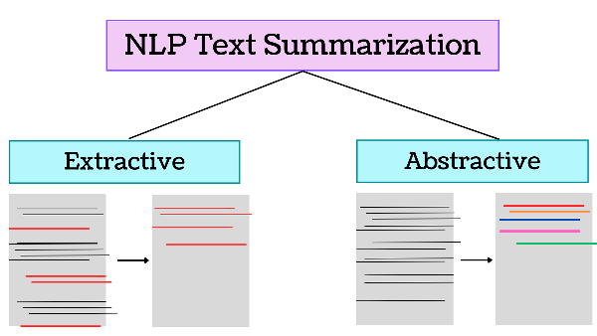

### **Slide 8: Introduction to Rhetorical Structure Theory (RST)**

****Title****: Understanding Rhetorical Structure Theory (RST)

****Content****:

* ****Definition****: RST is a framework used to analyze the logical and hierarchical structure of texts, identifying relationships between various parts of the text to understand how they contribute to the overall coherence and purpose.
* ****Origin****: Developed by William Mann and Sandra Thompson in the 1980s, RST was initially aimed at improving human and machine text generation and understanding.
* ****Importance****: RST aids in deciphering the underlying structure of texts, which is crucial for tasks like text summarization, where understanding the text's organization and thematic progression is key.

### **Slide 9: Key Concepts in RST**

****Title****: Fundamental Concepts in Rhetorical Structure Theory

****Content****:

* ****Nucleus and Satellite****: The basic units of RST analysis. The nucleus represents the core information, while satellites provide supporting information, elaboration, or contrast.
* ****Rhetorical Relations****: Describes the relationship between nucleus and satellites, such as cause-effect, elaboration, contrast, and evidence. These relations help in understanding how a text constructs meaning and guides its reader.
* ****Hierarchical Organization****: Texts are viewed as a hierarchy of rhetorical units, with each level providing different degrees of detail and insight into the text's purpose and structure.

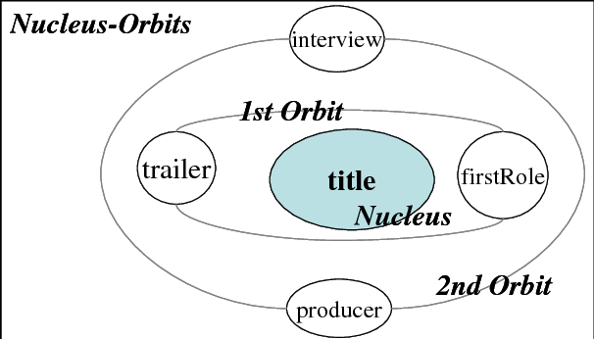

### **Slide 10: Applying RST in Text Summarization**

****Title****: RST's Role in Text Summarization

****Content****:

* ****Extractive Summarization****: RST can guide the selection of key sentences (nuclei) that are central to the text's meaning, ensuring that summaries are coherent and focused on the main themes.
* ****Abstractive Summarization****: By understanding the hierarchical structure and rhetorical relations within a text, summarization models can generate summaries that not only condense information but also maintain the logical flow and coherence of the original text.
* ****Challenges and Opportunities****: Discuss the challenges of integrating RST into computational models due to its complex and nuanced analysis. However, advancements in NLP and machine learning present opportunities for more sophisticated summarization tools that better understand and replicate human-like summarization.

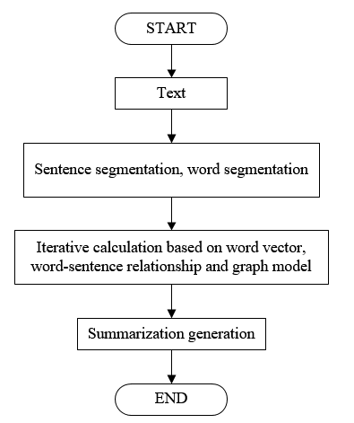

### **Slide 11: Tools and Software that Use RST**

****Title****: RST Applications: Tools and Software

****Content****:

* ****Overview****: Introduce how RST principles have been integrated into various text analysis and generation tools, enhancing their capability to understand and manipulate text structure coherently.
* ****RSTTool****: A software application designed for annotating texts with Rhetorical Structure Theory. It's used in academic research to manually analyze and visualize the rhetorical structure of texts.
* ****SciSummNet****: A corpus and set of tools developed for scientific document summarization, leveraging RST to enhance the summarization process, particularly for understanding argumentative structures in scientific writing.
* ****GIST****: An automatic text summarization tool that uses RST to improve the coherence and quality of summaries by identifying and preserving the text's logical and hierarchical structure.

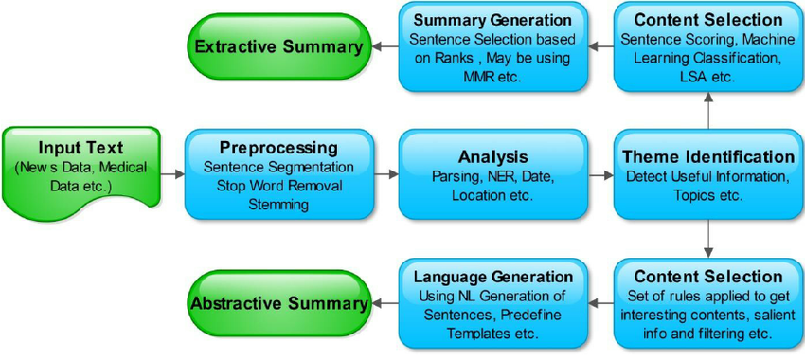

### **Slide 12: Example of RST Analysis in a Document**

****Title****: RST in Practice: Analyzing a Text Document

****Content****:

* ****Objective****: Demonstrate how RST can be applied to a specific text document to uncover its structural and rhetorical organization.
* ****Process****:
  + Briefly describe selecting a text passage.
  + Illustrate the identification of nuclei and satellites, along with the rhetorical relations connecting them.
  + Show how this analysis informs the hierarchical organization of the text.
* ****Outcome****: Explain how this RST analysis provides insights into the text's coherence and structure, which can guide effective summarization strategies.

### **Slide 13: Introduction to Multiple Document Summarization**

****Title****: Beyond Single Documents: Summarizing Multiple Texts

****Content****:

* ****Definition****: Multiple Document Summarization (MDS) involves creating a concise summary from a set of related documents, focusing on extracting or generating information that captures the main points across all texts.
* ****Importance****: MDS is crucial for synthesizing information from multiple sources, such as news articles on the same event, scientific articles on similar topics, or customer reviews of a product, providing a comprehensive overview.

### **Slide 14: Challenges Unique to Multiple Document Summarization**

****Title****: Navigating the Complexities of MDS

****Content****:

* ****Information Redundancy****: Identifying and managing overlapping information across documents to avoid repetition in the summary.
* ****Diverse Perspectives****: Balancing different viewpoints and interpretations of the same topic or event to create an unbiased summary.
* ****Document Heterogeneity****: Handling variations in document style, format, and quality, which can affect the consistency and coherence of the summary.
* ****Scalability****: Developing summarization approaches that efficiently process a large number of documents without compromising summary quality.

### **Slide 15: Techniques and Algorithms for Multiple Document Summarization**

****Title****: Approaches to Tackling MDS

****Content****:

* ****Cluster-Based Summarization****: Grouping similar content across documents into clusters to identify central themes, using techniques like Latent Dirichlet Allocation (LDA) for topic modeling.
* ****Cross-Document Structure Theory (CST)****: An extension of RST for multiple documents, CST helps identify and relate information across texts to maintain coherence in summaries.
* ****Graph-Based Methods****: Constructing inter-document graphs that represent similarities and relations between different texts, facilitating the identification of important information spread across documents.
* ****Machine Learning and Deep Learning Approaches****: Utilizing advanced algorithms, including neural networks, for both extractive and abstractive MDS, enabling more nuanced understanding and generation of summaries.

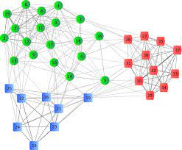

### **Slide 16: Importance of Clustering in Multiple Document Summarization**

****Title****: The Critical Role of Clustering in MDS

****Content****:

* ****Purpose****: Clustering groups together similar information across multiple documents, aiding in identifying central themes and reducing redundancy.
* ****Techniques****: Highlight popular clustering algorithms such as K-means, Hierarchical Clustering, and DBSCAN, explaining their use in identifying similar content.
* ****Benefits****:
  + Enhances the efficiency of summarization by focusing on unique information clusters.
  + Ensures comprehensive coverage of topics by identifying all relevant themes.
  + Aids in organizing the summary by thematic areas, improving readability and coherence.

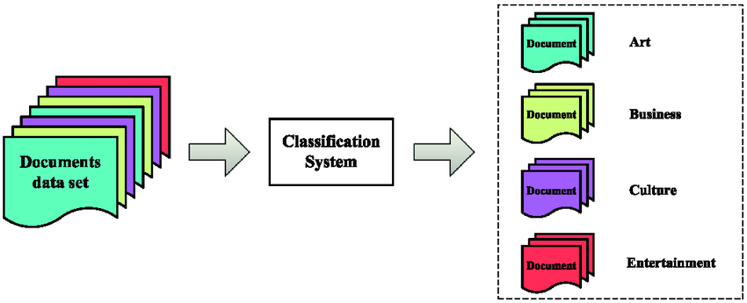

### **Slide 17: Case Study - Multiple Document Summarization**

****Title****: Case Study: Summarizing a News Event from Multiple Sources

****Content****:

* ****Background****: Present a news event covered by multiple media outlets, highlighting the diversity of sources and perspectives.
* ****Process****:
  + Demonstrate the clustering of articles based on similarities and differences in coverage.
  + Show how key points are extracted or generated from each cluster to form a comprehensive summary.
* ****Outcome****: Share the final summary, emphasizing how it encapsulates diverse viewpoints and central facts, providing a balanced and concise overview of the event.

### **Slide 18: Recent Advances in Text Summarization**

****Title****: Innovations Shaping the Future of Text Summarization

****Content****:

* ****Deep Learning****: Discuss how models like BERT, GPT-3, and T5 have revolutionized summarization by improving understanding and generation of concise, relevant content.
* ****Reinforcement Learning****: Highlight applications where summarization systems learn and improve based on feedback, optimizing for more accurate and user-specific summaries.
* ****Multimodal Summarization****: Introduction to summarization techniques that incorporate not just text, but also audio, video, and images for a richer, more comprehensive summary.

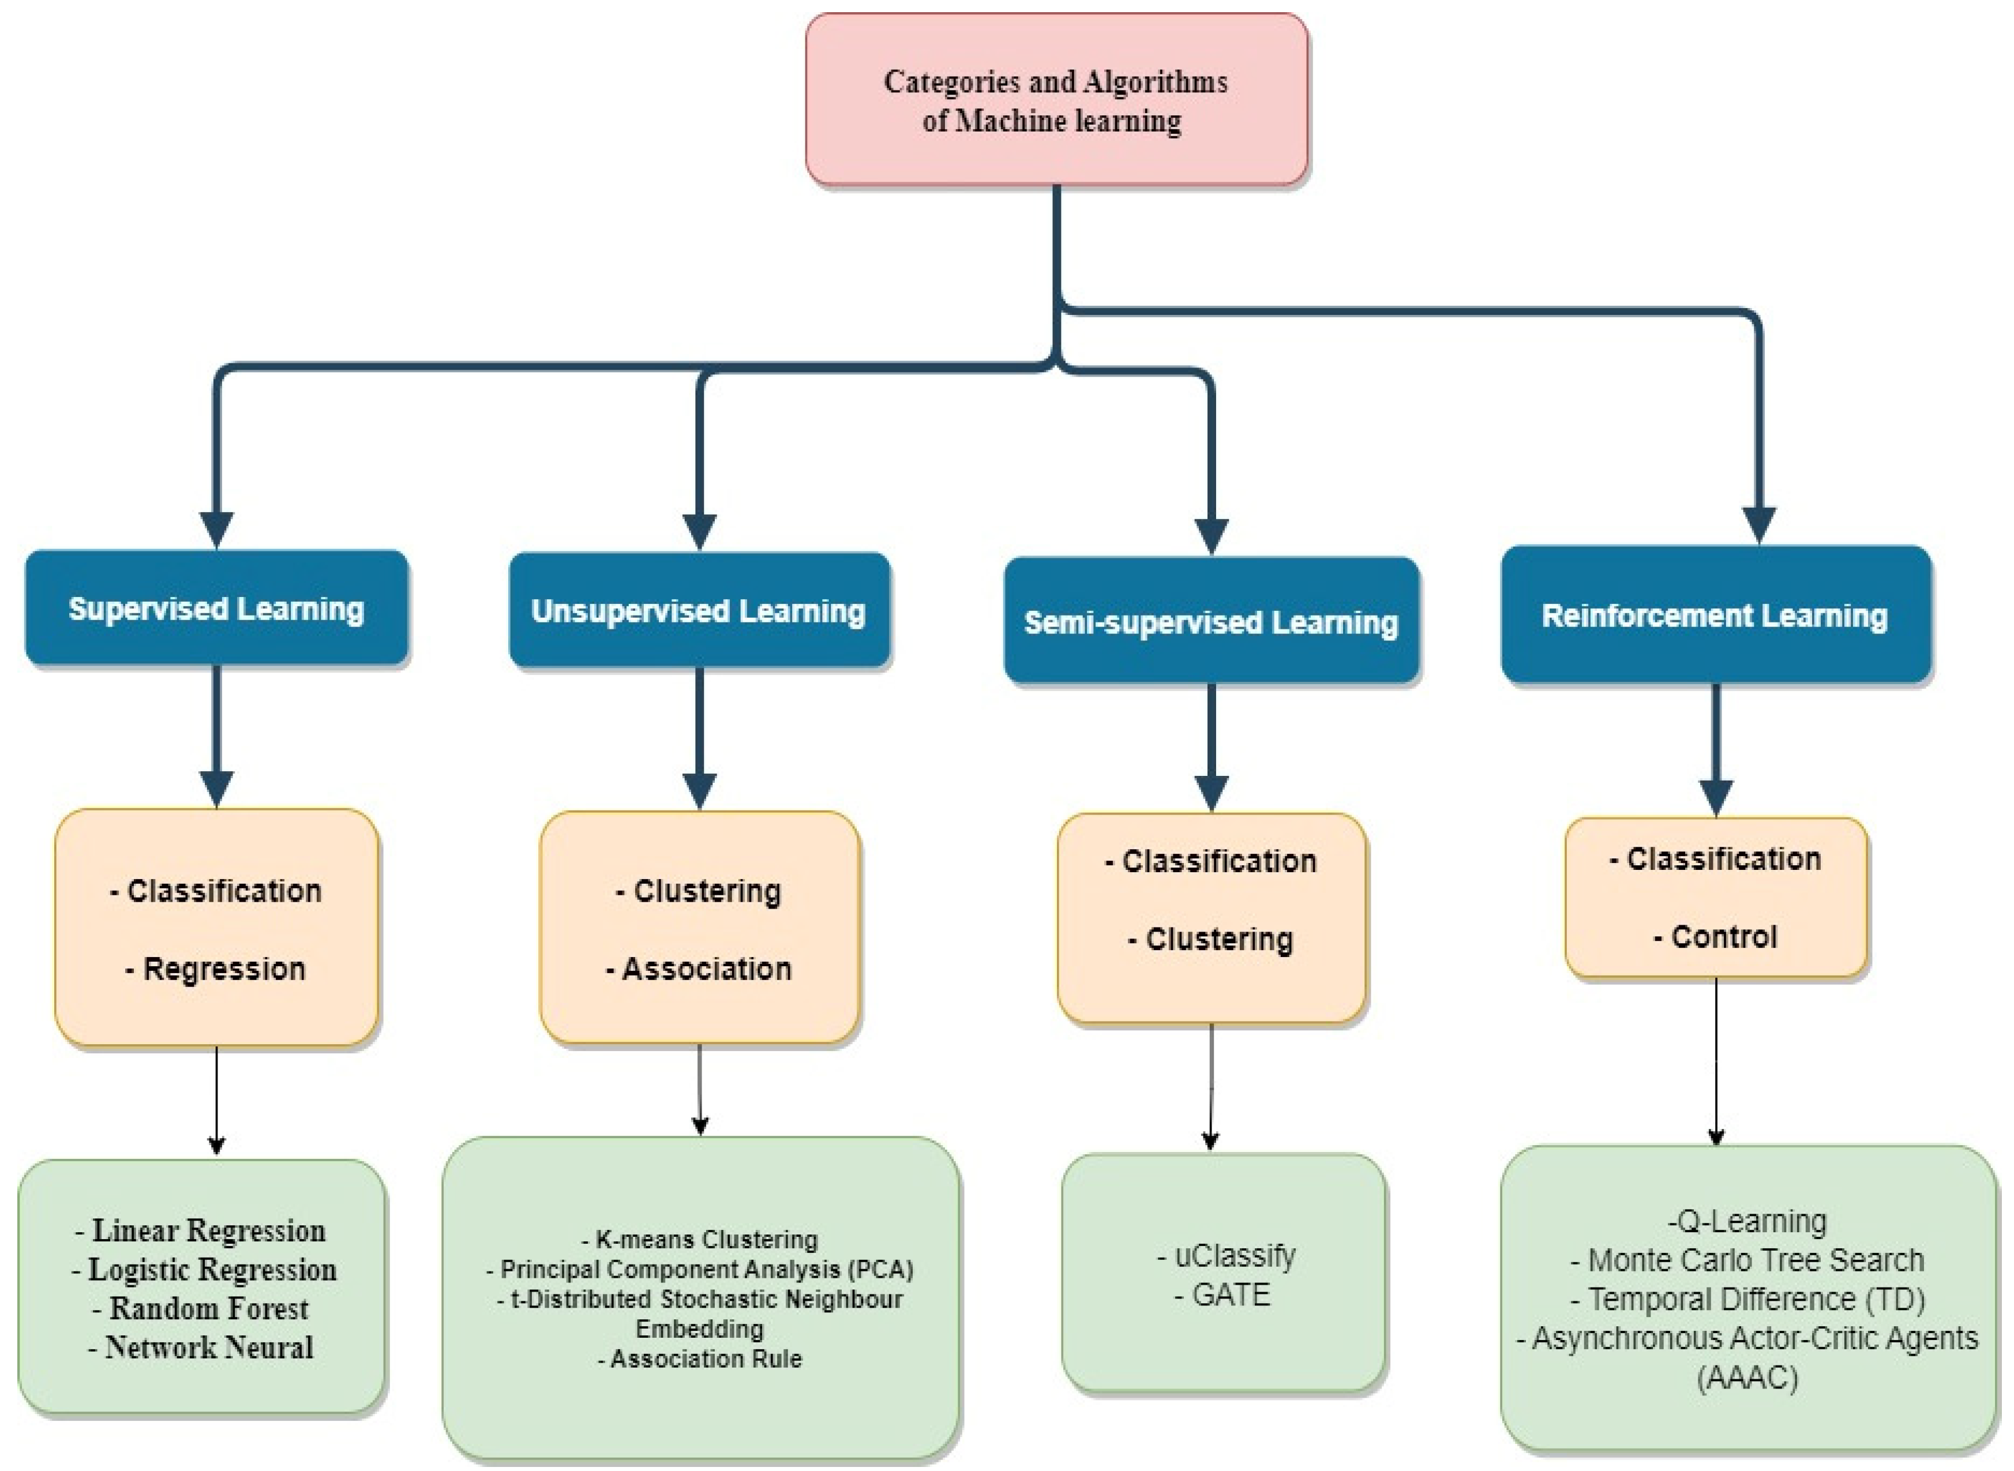

### **Slide 19: Ethical Considerations and Challenges**

****Title****: Navigating the Ethics of Text Summarization

****Content****:

* ****Bias and Fairness****: Address the potential for inherent biases in training data to influence summarization outcomes, impacting neutrality and fairness.
* ****Privacy and Data Protection****: Discuss concerns related to using sensitive or personal information in summarization, emphasizing the need for robust data protection measures.
* ****Misinformation****: Highlight the risk of summarization tools being used to propagate misleading summaries or distort information, stressing the importance of transparency and accuracy.

### **Slide 20: Future Directions in Computational Linguistics and Text Summarization**

****Title****: What Lies Ahead: Text Summarization and Computational Linguistics

****Content****:

* ****Interdisciplinary Research****: Encourage the exploration of how insights from psychology, rhetoric, and linguistics can inform the development of more intuitive and effective summarization tools.
* ****Interactive Summarization****: Forecast the rise of summarization systems that allow users to specify interests or questions, generating customized summaries.
* ****Global Language Support****: Stress the importance of advancing summarization capabilities for a broader range of languages, promoting inclusivity and accessibility in information consumption.

